Assignment 22

Name: Jeevan Sai Badana

Mail: [jeevansai100@gmail.com](mailto:jeevansai100@gmail.com)

Topic: Copy activity in data factory

Let’s create the storage accounts first:

Here we create sourcedata1059 storage account for souce and in container we create con1 container and upload some random data

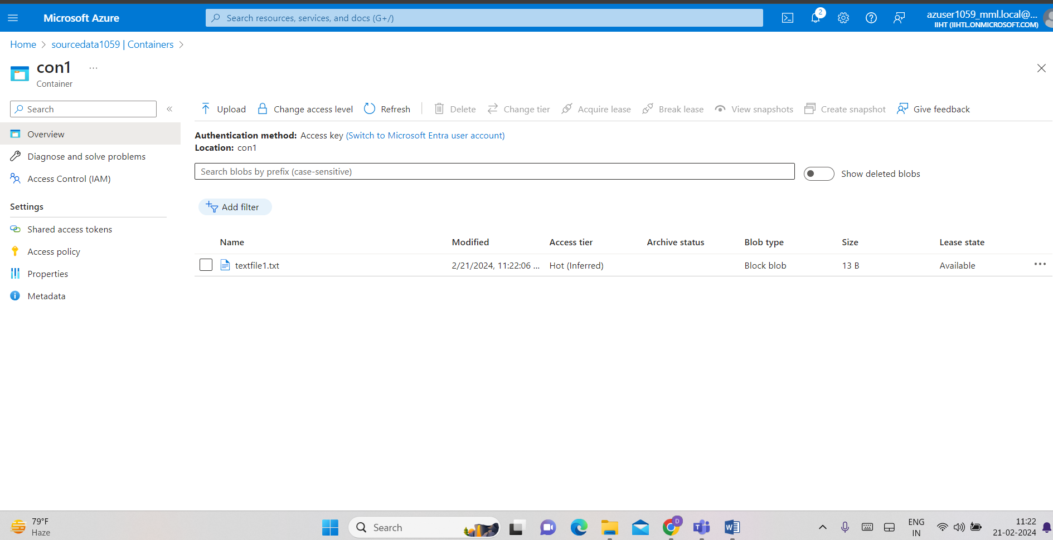

Now we create destination storage account as desdata1059 and in that create a new container con2 and do not upload any data

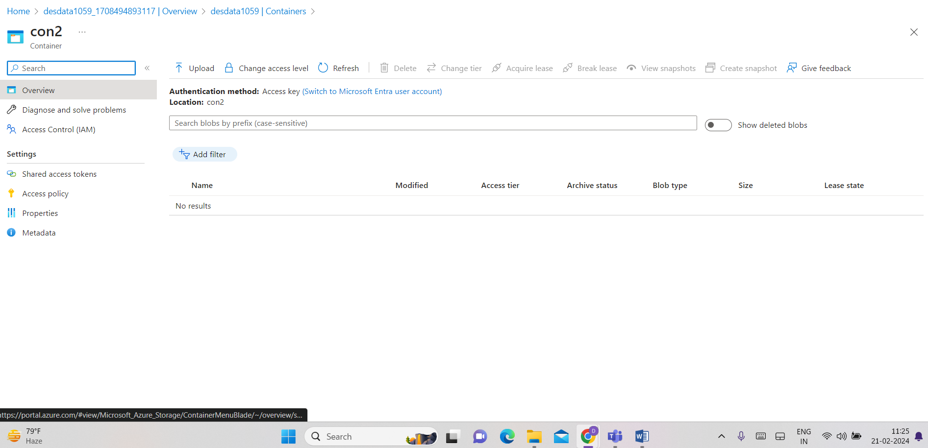

Now we can create jeevandf datafactory

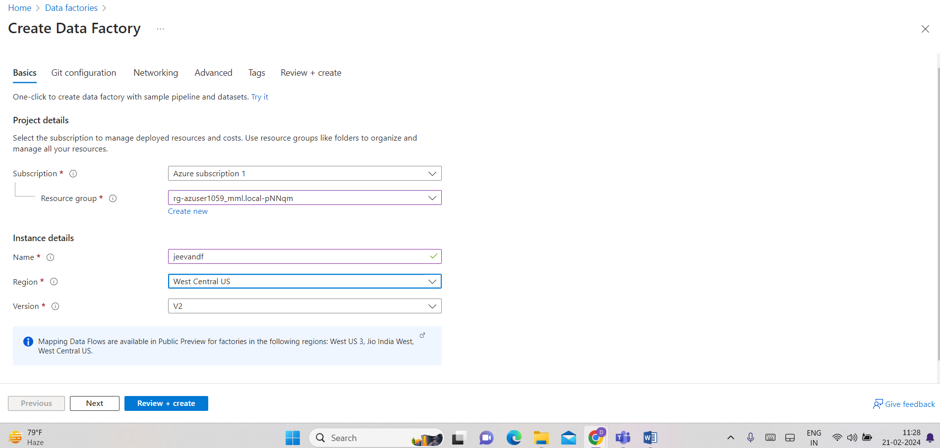

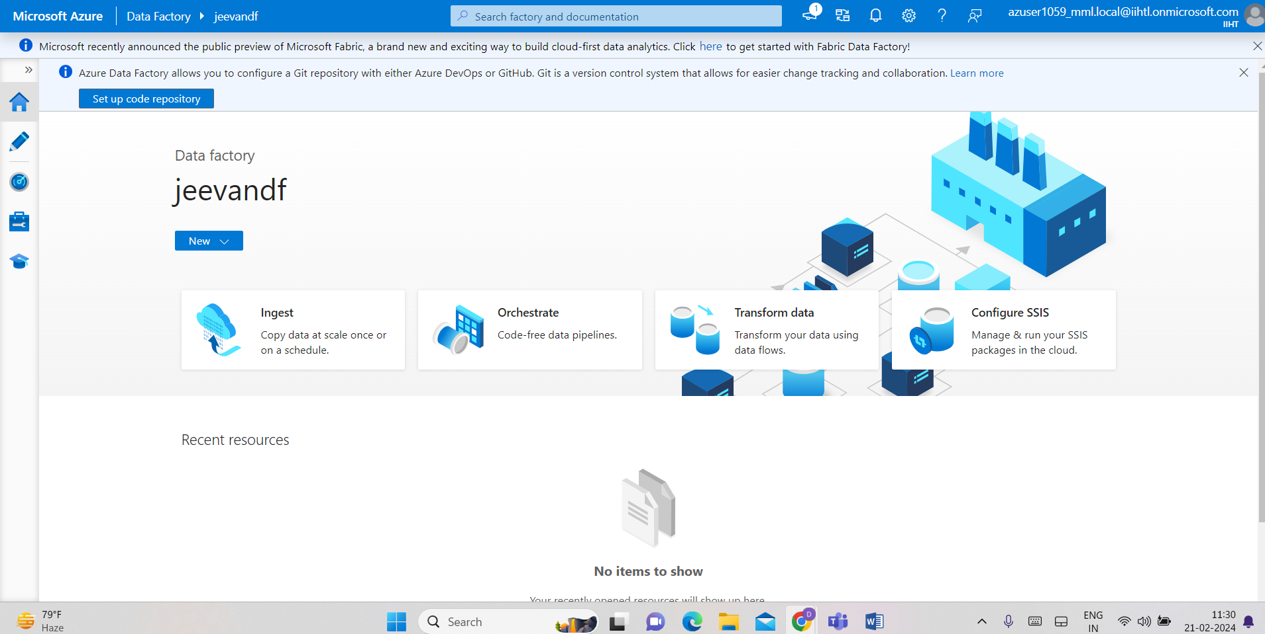

Click on ingest

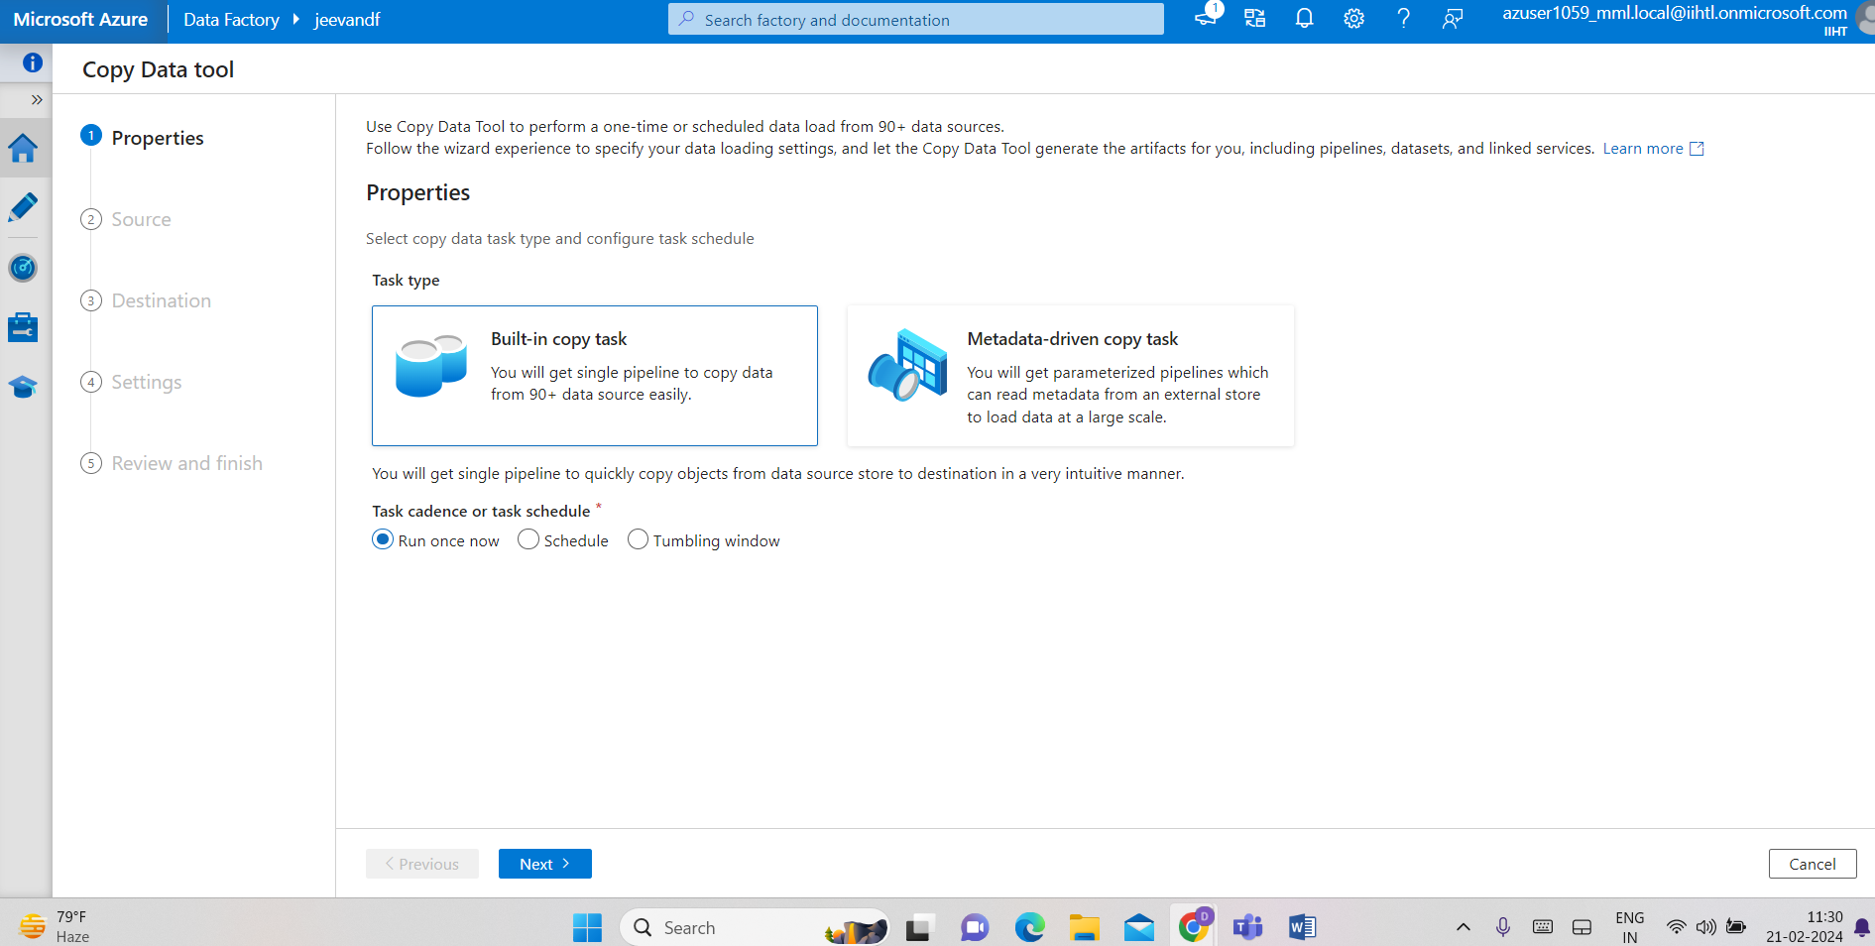

Now we give source data details

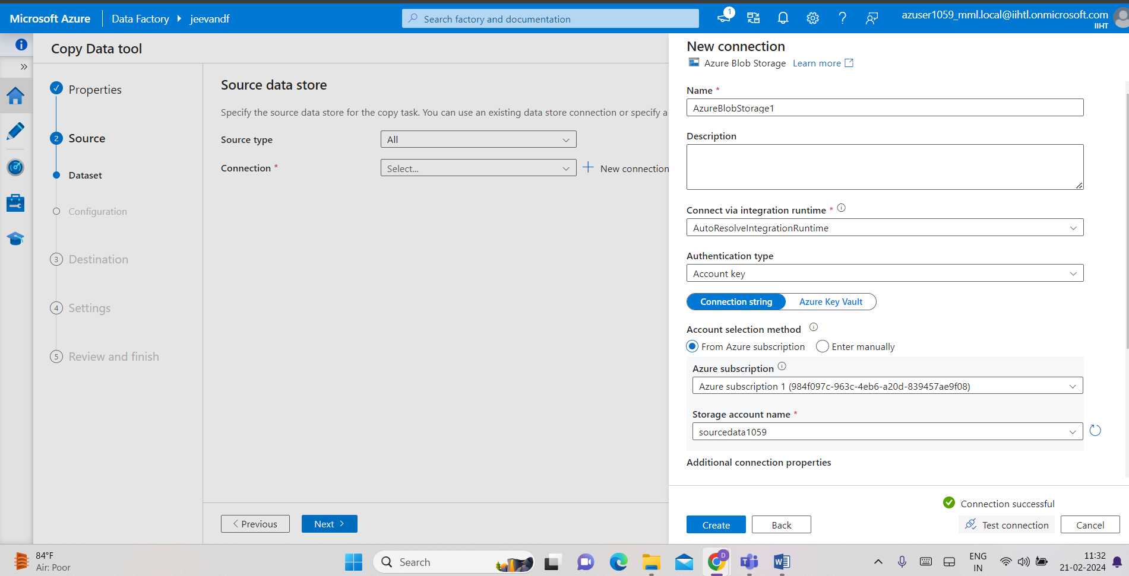



Now give destination details

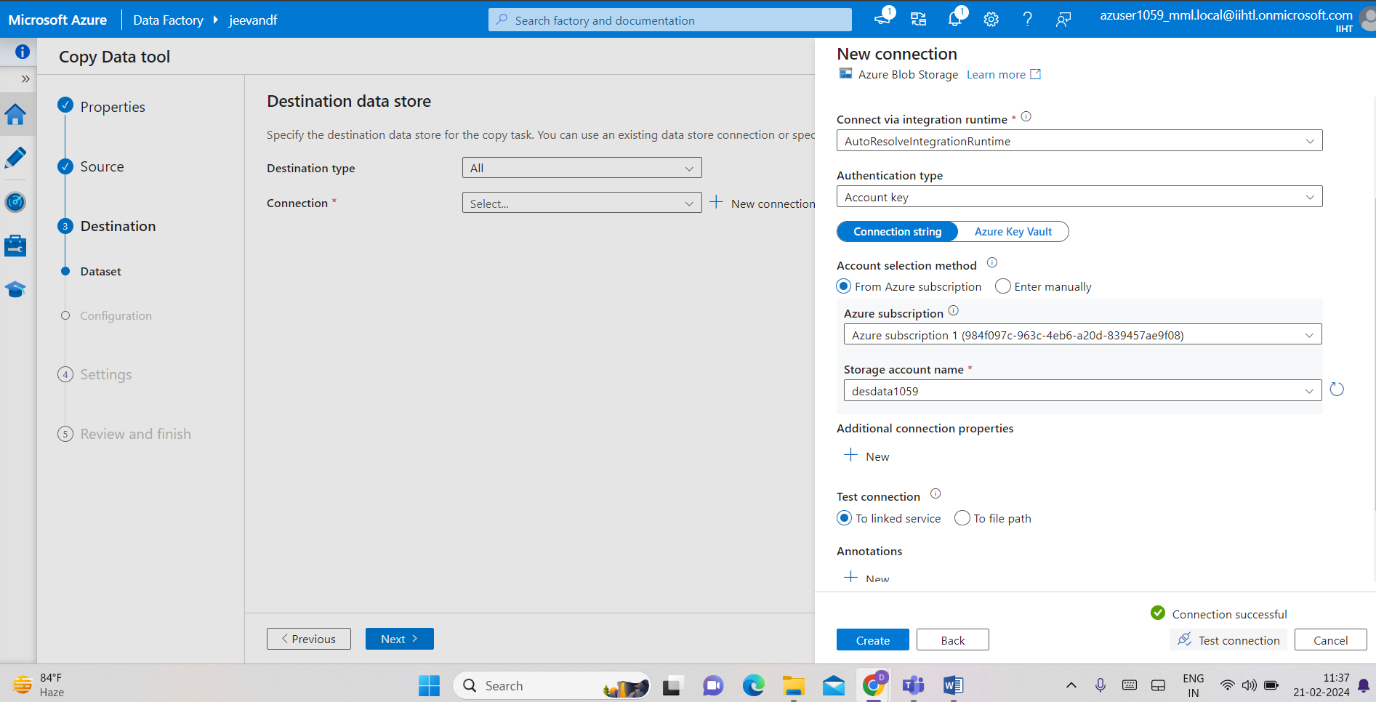

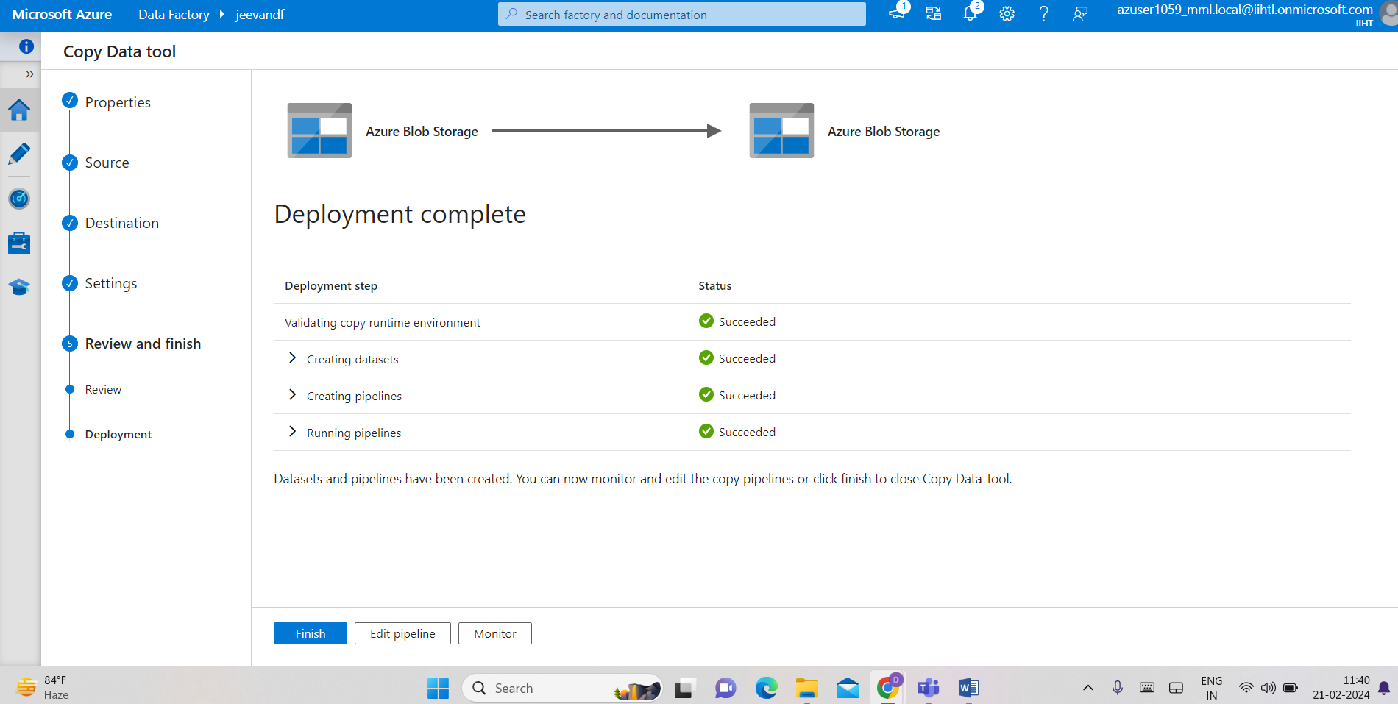

Now we find the copied data in con2 destination data

